Name – Shaurya Singh Srinet

Reg No – RA2111032010006

Branch – CSE w/s in IoT

Section – T2

Object Oriented Design and Programming

Assignment: Week 4: -

3. Write C++ Program to display the cube of the number up to a given integer using Destructor.

Code: -

#include <iostream>

using namespace std;

class Cube

{

public:

int n,i;

Cube(int n1)

{

n=n1;

}

void display()

{

for(i=1;i<=n;i++)

cout<<"Cube of "<<i<<": "<<i\*i\*i<<endl;

}

~Cube()

{

cout<<"Destructor method called";

}

};

int main()

{

int n;

cout<<"Enter a number to get the cubes till that number: ";

cin>>n;

Cube c1=(n);

c1.display();

return 0;

}

Input and Output: -

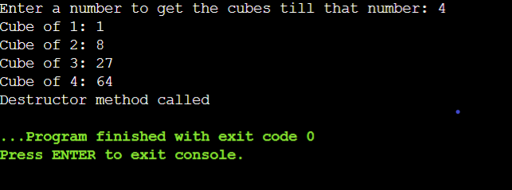

4. Write a C++ Program to calculate Volume of Cube using constructor and destructor.

Code: -

#include <iostream>

using namespace std;

class Cube

{

public:

int a;

Cube(int n1)

{

a=n1;

}

void display()

{

cout<<"Volume of the cube: "<<a\*a\*a<<endl;

}

~Cube()

{

cout<<"Destructor method called";

}

};

int main()

{

int a;

cout<<"Enter the side of the cube to calculate its volume: -\n";

cin>>a;

Cube c1=(a);

c1.display();

return 0;

}

Input and Output: -

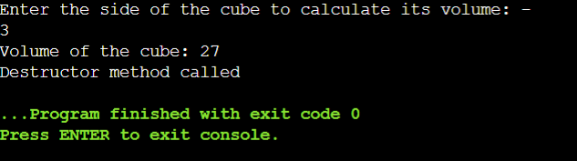

6. Write a C++ program to find the number and sum of all integer between 100 and 200

which are divisible by 9 with constructor destructor.

Code: -

#include <iostream>

using namespace std;

class Nine

{

public:

int i,s=0;

Nine()

{

cout<<"All the numbers divisible by 9 between 100 and 200 are: -\n";

for(i=100;i<=200;i++)

if(i%9==0)

{

cout<<i<<endl;

s=s+i;

}

cout<<"The addition of all the numbers are: "<<s;

}

~Nine()

{

cout<<"\nDestructor method called";

}

};

int main()

{

Nine c1;

return 0;

}

Input and Output: -

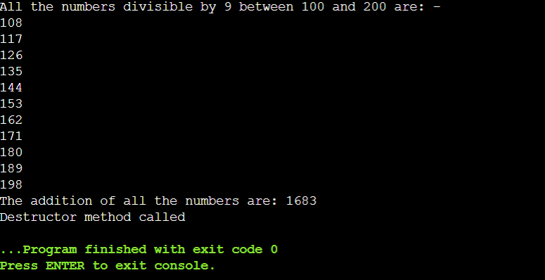

8. Write C++ program to demonstrate example of Parameterized Constructor.

Code: -

#include <iostream>

using namespace std;

class Nine

{

public:

Nine(int n1,int n2)

{

cout<<"The addition is: "<<n1+n2;

}

};

int main()

{

int s1,s2;

cout<<"Enter two numbers to find their addition: -\n";

cin>>s1>>s2;

Nine c1(s1,s2);

return 0;

}

Input and Output: -

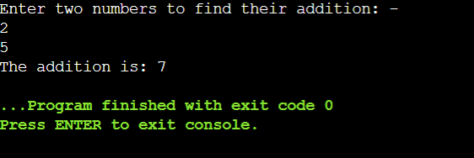

9. One of the famous politician was admitted in one of the famous hospital.

Code: -

#include <iostream>

using namespace std;

class Nine

{

public:

Nine(int n1,int n2)

{

cout<<"The total bill is: "<<n1\*n2;

}

};

int main()

{

int s1,s2;

cout<<"Enter the amount of medicine: -\n";

cin>>s1;

cout<<"Enter the number of days: -\n";

cin>>s2;

Nine c1(s1,s2);

return 0;

}

Input and Output: -

